GENERAL TERMINOLOGY
- Entity Class/Set = Description of a set of entities
- Connectivity = 1:1, 1:M, M:N
- Cardinality = min/max number of entities in a relationship per side
- Domain = Set of possible values for an attribute
- Database Management System (DBMS) = Tech for storage, retrieval, and management of data.
- SQL = Structured Query Language; programming lang used to handle relational data
- SQL Server = data server that incorporates SQL
BASICS OF DATABASES
Database = Collection of records that, through processing, produce information
- Databases make data persistent and shareable in a secure way
- Databases allow systems to store, manage, and retrieve data quickly
- Contain entities, attributes, and relationships

Types of databases
- Single-user = one user supported at a time
  - Desktop database – personal computer
- Multi-user = multiple users supported at a time
  - Workgroup – small # of users, Enterprise – many users

Database classification – Databases classified by how they are used
- Operational Database = day-to-day operations
  - OLTP, Online Transaction Processing
- Data Warehouse = historical data; planning, problem solving, decision making
  - OLAP, Online Analytical Processing
DATABASE DESIGN
Database design focuses on database structures
- Well designed databases facilitate data management and generate good information; poor design causes errors and poor decision making

Requirements of good database design
1. Preserve relationships between data 3. Avoid redundancy in data storage
2. Store all data

Database Design Process
1. Business rules and user’s view of the data 3. Create an implementation model
2. Build an ERD 4. Physically store the data
RESULTS OF DATA REDUNDANCY | DATA ANOMALIES
- Poor data security | Not all changes are made successfully
- Data Inconsistency | - Update Anomalies (update many fields)
- Data Entry Errors | - Insertion Anomalies (constraint, redund.)
- Data Integrity problems | - Deletion Anomalies (delete necessary data)
DBMS
DBMS Functions
- Multiuser access control
- Backup and recovery management
- Data integrity management

DBMS Functions
- Data Dictionary Management
  - Data Dict = definitions of data elements and their relationships
- Data Storage Management
  - Performance tuning
- Data Transformation and Presentation
  - Data fits logical expectations
- Security Management
  - Ensure user security and data privacy
SQL & SQL Servers
SQL Statements – together = CRUD
- Data Definition Language (DDL) = Define/manage database structure
  - CREATE statement; create object
- Data Manipulation Language (DML) = Retrieve/manipulate data
  - SELECT statement; retrieve data
  - INSERT statement; store data
  - DELETE statement; delete data
  - UPDATE statement; update data
NULLS
Null = absence of any data value
- Flags = codes that indicate the absence of a value
- Constraints = force every cell to be full; NOTNULL constraint
ENTITY INTEGRITY
- All primary keys are unique
- Primary key does not contain null values
REFERENTIAL INTEGRITY
Referential Integrity = table relationships maintained; PK/FK same data type
- Non-null FKs in a table have a corresponding PK in another table

If referential integrity is not enforced and a row is deleted from the PK that has related rows in the FK, the FKs have been ORPHANED

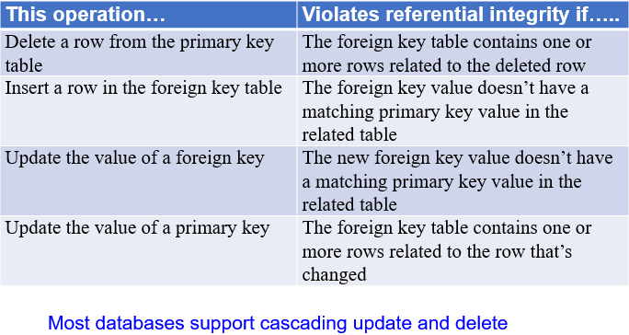
RELATIONAL SET OPERATORS
- SELECT – unary; horizontal subset of a table
- PROJECT – unary; vertical subset of a table
- UNION – combines rows from tables except duplicates; UNION COMPATIBLE
- INTERSECT – yield rows that are in both tables; UNION COMPATIBLE
- DIFFERENCE – yield rows in one table but not the other; UNION COMPATIBLE
- PRODUCT – yield all possible pairs of rows
  - UNION COMPATIBLE – same columns/datatypes in both tables
ENTITY RELATIONSHIP DIAGRAM (ERD)
Simple (atomic) vs composite attributes – break apart CAs
Single-valued vs multi-valued attributes – new table MVs
Stored vs Derived attributes - / before derived attribute
Unary vs binary
|,0 = Optional or mandatory Underline PK
>,| = Many or 1-1 Italic FK or (FK)
Composition Relationship = diamonds

Subtype Discriminator
Od, Oo = distinct vs overlap Distinct makes new subtype discrim table
-,= = partial vs total completeness Overlap uses attributes in supertype

ERD Process
1. Understand business 4. Develop ERD
2. Find business rules 5. Identify attributes and PKs for entities
3. Identify entities and relationships 6. Revise/review ERD
EXISTENCE DEPENDENCE
Existence Dependence = entity only exists when associated with another entity
Existence Independence = entity exists regardless of other entities; strong entities
Weak Entities = Existence dependent AND PK partially/totally derived from parent
DEPENDENCIES
Functional Dependencies = A 1:1 with B; A->B
Partial Dependencies = B dependent on part of A; composite PK only
Transitive Dependencies = A -> B -> C
- FDs good, TDs and PDs bad
NORMALIZATION
Process of making inefficient tables into neat entities
- 1NF – No CompAtts, no MvAtts, no RGs, proper PK
- 2NF – 1NF and no partial dependencies
- 3NF – 2NF and no transitive dependencies

Denormalization = Reducing a higher form to a lower form for efficiency
CONVENTIONS
Entity
- NAME - Unique nouns, good documentation of abbreviation, synonyms, aliases
- One subject, 3NF, granularity defines, PK defined

Attribute
- NAME - Unique, use entity prefix, descriptive, use suffixes, no reserved words, no spaces or special characters
- Single-valued, good documentation, not redundant, functional dependencies

Relationship
- NAME – Verbs
- Identify relationships and define participation/connectivity/cardinality

ER Model
- Validated against anomalies, evaluate history, no redundant relationships, no data redundancy, minimal data

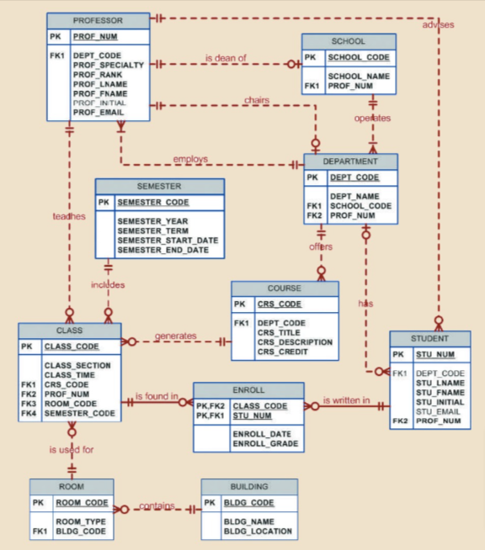
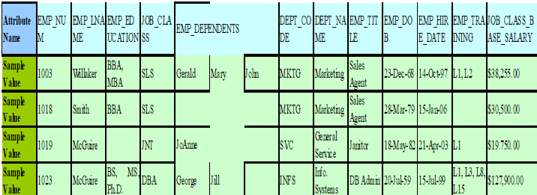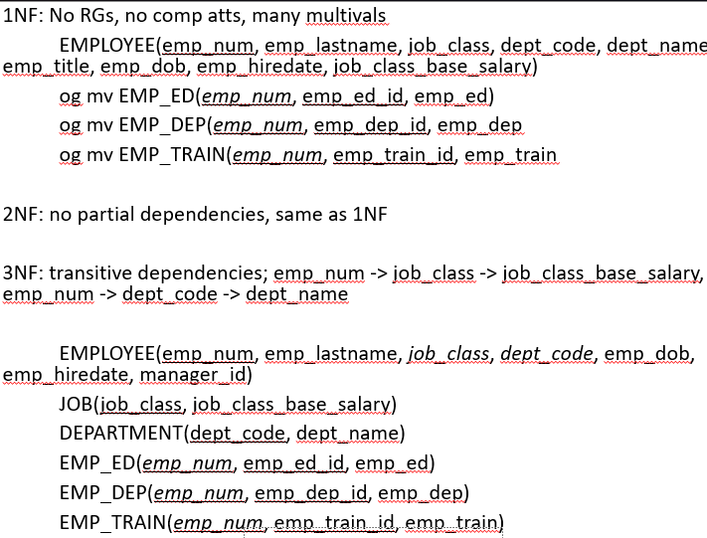

ENTITY RELATIONSHIP DIAGRAM (ERD)
Simple (atomic) vs composite attributes – break apart CAs
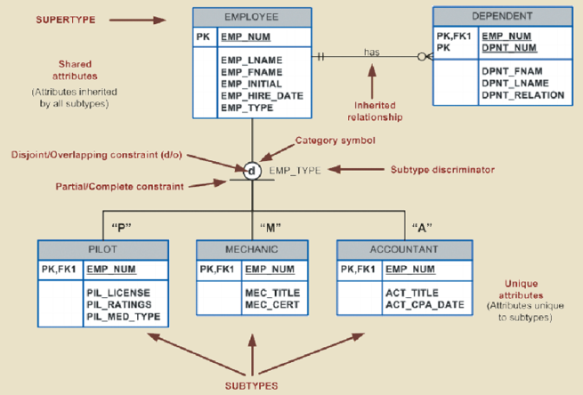
Single-valued vs multi-valued attributes – new table MVs
Stored vs Derived attributes - / before derived attribute
Unary vs binary
|,0 = Optional or mandatory Underline PK
>,| = Many or 1-1 Italic FK or (FK)
Composition Relationship = diamonds
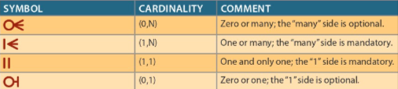
Subtype Discriminator
If new subtype discrim table, the PK in the table becomes an FK in the supertype
Od, Oo = distinct vs overlap Distinct makes new subtype discrim table
-,= = partial vs total completeness Overlap uses attributes in supertype

ERD Process
1. Understand business 4. Develop ERD
2. Find business rules 5. Identify attributes and PKs for entities
3. Identify entities and relationships 6. Revise/review ERD
EXISTENCE DEPENDENCE
Existence Dependence = entity only exists when associated with another entity
Existence Independence = entity exists regardless of other entities; strong entities
Weak Entities = Existence dependent AND PK partially/totally derived from parent
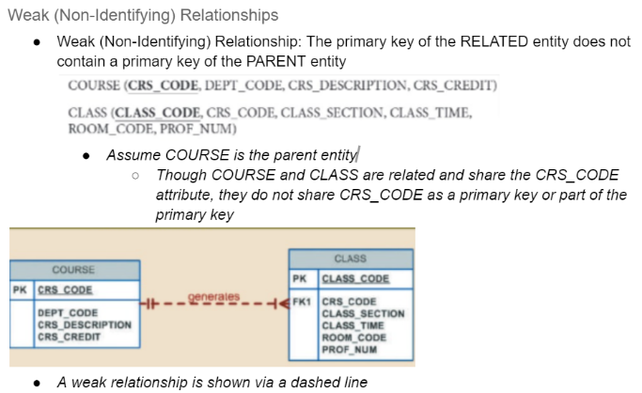
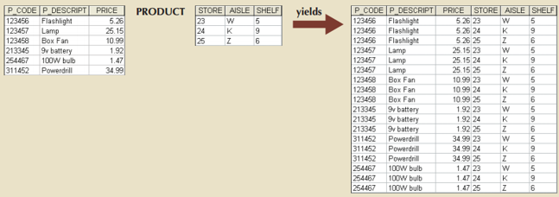
DEPENDENCIES
Functional Dependencies = A 1:1 with B; A->B
Partial Dependencies = B dependent on part of A; composite PK only
Transitive Dependencies = A -> B -> C
- FDs good, TDs and PDs bad
NORMALIZATION
Process of making inefficient tables into neat entities
- 1NF – No CompAtts, no MvAtts, no RGs, proper PK
- 2NF – 1NF and no partial dependencies
- 3NF – 2NF and no transitive dependencies

